**Welcome to the study**

In this study you will play five lottery games against other players. In each game you will randomly assigned to play against another player.

In each game there are two urns. Each urn includes 100 numbered balls. The numbers of the balls represent amounts of money that you get as a Bonus regarding your decisions at the end of the study. Each player starts with an entry fee of 5 CHF. You will win or lose money based on the outcomes of the urn that you choose.

This is what the urns look like:



Neither you nor the other player knows before every single game, what amounts of money are included in the urns. To find this out, both players have the possibility to inspect the urns before they decide. These are the **Information Rounds**. If a player decides to choose an urn after an Information Round, the **Decision Round** will follow for both players.

I) Each game will start with the first **Information Round**. In this round, you can click on one of the two urns to pick a ball. Thus, you inspect the urns. When both players clicked on an urn, you will see the amount of money of the ball on that you have clicked. You will see as well, which urn the player has chosen. But you will not see, what amount of money the ball shows that he has picked, but a star (*).  
After that, the balls will be put back in the urns.

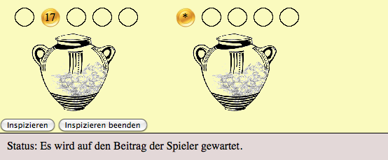

II) Now you can decide if you want to continue inspecting the urns and have another **Information** **Round**. In this case you will click on “inspect”.  
If you don’t want to continue inspecting the urns, you can go to a **Decision Round** by clicking on “quit inspecting”.

III) If you have decided for another **Information Round**, there are two possibilities:

* If the other player decided for an **Information Round,** the **second Information Round** starts.
* If the other player decided for a **Decision Round**, he or she will chose an urn. IMPORTANT: Because both players cannot choose the same urn during the Decision Round, you can only chose the urn that the other player hasn’t chosen.

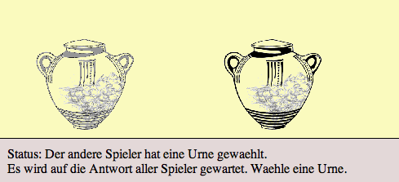

IV) If you have decided for a **Decision Round**, you have to choose an urn. You click on the urn, which you have decided to choose.

If the other player decided for an **Information Round**, you are free in choosing.   
The other urn will be assigned to the other player.

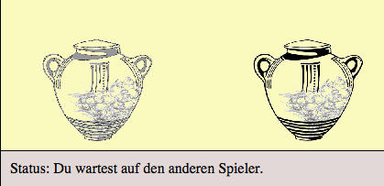

If the other player decided for the **Decision Round**, there are two possibilities that can happen:

* If you and the other player choose different urns, you will each get the urn of your choice.
* If you and the other player choose the same urn, the computer will randomly choose one of you to receive the urn, and the other player will receive the non-chosen urn.

A lottery game is over after a Decision Round. Another game of the total five lottery games will follow with new urns and new balls.

You can decide how often you want to inspect the urns. There is no maximum number of Information Rounds. As long as both players decide for Information Rounds, the inspection of the urns will continue.

You will get money regarding your decisions at the end of the experiment. From each urn that you have chosen or that was assigned to you,

SAMPLE REWARD CONDITION: [a ball will be drawn by chance from the chosen urn and you will get the amount of money of this ball.]  
MEAN REWARD CONDITION: [you will receive the average amount of all balls in this urn. For example: If an urn includes 50 balls with -5 and 50 balls with 15 CHF, then you will receive 5 CHF.]

An urn can include positive as well as negative amounts of money. Because of that it can happen, that you may lose money.  
At the end you will receive the total amount of money of the five lottery games.

It could happen that sometimes you have to wait till the other player made his decision. Please wait calmly till the game will go on.

Any questions?

Now three practice games will follow, so you can learn the rules.  
Maybe this sounds a little bit complicated for the moment. After the 3 practice games you will see, that the rules are easy. You can ask questions anytime to the experimenter during the practice games.

Have fun! ☺